भारतमौसमविज्ञानविभाग |  | India Meteorological Department
Saturday, 28th June 2025 (7th Ashadha 1947 Saka)
Summary of observations recorded at 0830 hours IST: The Northern Limit of Monsoon continue to pass through 27.0°N/68.5°E, 27.0°N/70.0°E, Jaisalmer, Bikaner, Jhunjhunu, Bharatpur, Rampur, Sonipat, Anup Nagar and 29.0°N/70.0°E. Conditions are becoming favourable for further advance of Southwest monsoon over remaining parts of the country during next 2 days. The upper air cyclonic circulation lay over Saurashtra & Kutch & adjoining northeast Arabian sea and extended upto middle tropospheric level tilting southwestwards with height of today morning. Under the influence of the upper air cyclonic circulation over Saurashtra & Kutch & adjoining northeast Arabian sea, a low-pressure area formed over Saurashtra & Kutch at 0830 hrs IST of today, the 28th June, 2025. However, the associated upper air cyclonic circulation extended upto 7.6 km above m. s. l. tilting southwards with height persisted. An upper air cyclonic circulation lay over southwest Bangladesh & adjoining Gangetic West Bengal and extended upto 4.5 km above m. s. l. tilting southwestwards with height of today morning. It then persisted over the same region. Under its influence a low-pressure area is likely to form over the north Bay of Bengal and adjoining coastal Bangladesh and West Bengal during subsequent 48 hours. Subsequently it is likely to move slowly west-northwestwards across Gangetic West Bengal and north Odisha & Jharkhand. A cyclonic circulation lay over central parts of south Uttar Pradesh and extended upto 1.5 km above m. s. l. The east-west trough from the cyclonic circulation over southwest Rajasthan to Bangladesh now ran from the upper air cyclonic circulation over southwest Bangladesh & adjoining Gangetic West Bengal to northeast Madhya Pradesh across Jharkhand, north Chhattisgarh between 3.1 & 4.5 km above mean sea level. A cyclonic circulation lay over northeast Assam at 0.9 km above m. s. l. The upper air cyclonic circulation over southwest Rajasthan and extended upto 5.8 km above m. s. l. tilting southwest wards with height became less marked.
Day temperatures were markedly above normal (> 5.1°C) at isolated places over Assam & Meghalaya, Odisha and west Uttar Pradesh. appreciably above normal (3.1°C to 5.0°C) at few places over Arunachal Pradesh and Sub Himalayan West Bengal & Sikkim; at isolated places over Tamil Nadu, Puducherry & Karaikal. above normal (1.6°C to 3.0°C) at few places over east Uttar Pradesh and coastal Karnataka; at isolated places over Nagaland, Manipur, Mizoram & Tripura, Haryana-Chandigarh-Delhi, Himachal Pradesh, Rayalaseema and Kerala & Mahe. near normal(-1.5°C to 1.5°C) at many places over Gangetic West Bengal, Punjab, Jammu- Kashmir-Ladakh-Gilgit-Baltistan-Muzaffarabad and Madhya Maharashtra; at most places over Andaman & Nicobar Islands, Bihar, Konkan & Goa, Telangana, north interior Karnataka, south interior Karnataka and Lakshadweep; at few places over Uttarakhand, Marathwada, Vidarbha and coastal Andhra Pradesh & Yanam; at isolated places over east Rajasthan and Saurashtra & Kutch. Yesterday, the highest maximum temperature of 41.2°C was reported at Moradabad (Uttar Pradesh).
The Southwest Monsoon has been vigorous over east Madhya Pradesh and It has been subdued over Arunachal Pradesh, Assam & Meghalaya, Rayalaseema and south interior Karnataka.
Total 201 Station reported rainfall today. Total rainfall is 77.9 cm. Total 198 station reported rainfall today whose normals are available. Total rainfall is 77.9 cm with normal station total is 169.3 cm.
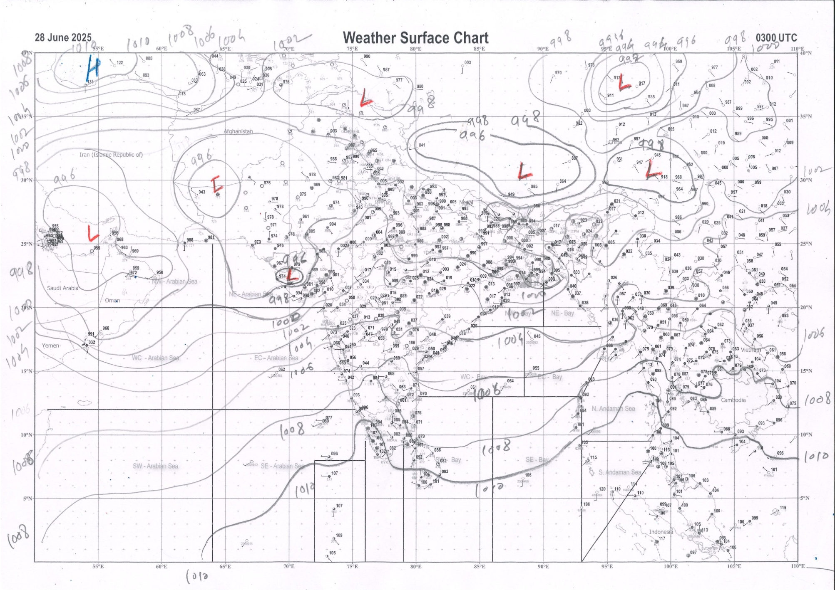 | 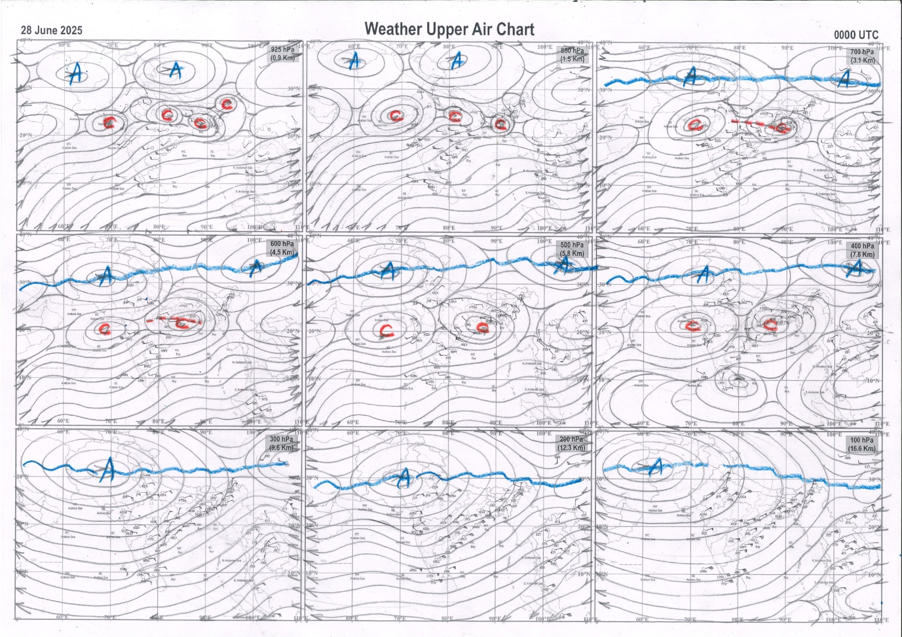
g.1. Analysed surface chart based on 03z observation | Fig.2. Analysed upper air chart based on 00z observation

Dr. S D Sanap.
Scientist ‘D’
CR & S Office, Pune  Issued at 1245 hrs. IST |  | Weather Forecasting Division  CR&S, Pune

Indian regions | Realised rainfall (chief amount in cm during past 24 hrs):
East | many places: Gangetic West Bengal+ and Jharkhand+  a few places: Arunachal Pradesh, Assam & Meghalaya, Sub-Himalayan West Bengal & Sikkim and Odisha+  isolated places: Nagaland-Manipur-Mizoram-Tripura and Bihar  Banspal 10.6, Hatadihi 8.8, Tenughat 7.7, Sagar island PTO 7.4, Balasore & Herhanj 7.1 each, Durgachack 7.0, Bodh gaya 5.8, Rafiganj 5.2, Kurti t.e. 4.4, Marigaon ARG 4.3, Dharamtul 4.2, Jiti t.e. 4.0, Dehri 3.1, Kamba AWS & Bankura 2.5 each, Chottabekra 2.4, Dhubri IMD 2.2, Dhanbad 1.6, Sabroom 1.4, Namsai 1.2, Cooch behar 0.8, Bomdila 0.4, Kohima 0.2.
North | most places: Uttarakhand+++  many places: Himachal Pradesh+  a few places: west Rajasthan+ and east Rajasthan  isolated places: Uttar Pradesh+, Haryana+, Punjab+ and Jammu-Kashmir and Ladakh  Chamoli 18.5, Jollygrant 16.9, Lohand 11.0, Ghorawal 10.1, Dehra dun 9.8, Kotla 9.6, Saharanpur 9.5, Tajewala 9.2, Robertsganj & Partapnagar REV 8.0 each, Jaisalmer 6.9, Palampur 6.7, Ramganjmandi SR 5.6, Hurda SR 5.2, Kasauli 4.8, Charkhari 4.6, Jaisalmer tehsil SR 3.9, Gadra road 3.8, Chandigarh 3.4, Dharampur 3.3, Jammu AWS 2.9, Alwar obs 2.8, Varanasi BHU 2.7, Poonch 1.8, Jalandhar 1.4, Katra 0.9, Jhansi 0.6.
Central | most places: east Madhya Pradesh+++  many places: Chhattisgarh+  a few places: west Madhya Pradesh+ and Vidarbha+  Devendranagar 13.0, Gonour 12.0, Panna-aws 10.4, Baloda 9.3, Sonakhan 8.4, Kuhi 7.0, Aron 6.5, Gondia AP & Mana-Raipur-AP 4.3 each, Vijaypur (adp) 4.2, Gondia 3.9, Datia-aws 1.8.
Peninsula | most places: Konkan & Goa+ and coastal Karnataka+  many places: Gujarat Region, Saurashtra & Kutch+ and Kerala+  a few places: Madhya Maharashtra+  isolated places: Marathwada, coastal Andhra Pradesh, Telangana, Rayalaseema, Tamil Nadu and interior Karnataka  Igatpuri 10.0, Kadra 8.6, Shahuwadi & Peermade to 8.4 each, Kalyanpur 7.7, Castle rock 7.6, Tellichery 6.7, Kankavli 6.6, Mandvi (k) 6.5, Mahabaleshwar 5.9, Dwarka & Agumbe emo 4.9 each, Silvassa & Vapi 4.7 each, Murbad 4.6, Valparai PTO & Gandarvakottai 4.0 each, Upasi tea research AWS 3.9, Kannur 3.7, Londa 3.5, Matheran 3.4, Kottigehara 2.8, Honavar 2.7, Kammardi 2.5, Sirpuru 1.9, Kollapur 1.8, Surat city 1.5, Satyavedu 1.4, Himayatnagar 1.3, Khanapur 1.1, Mudkhed 1.0, Tuni 0.4, Nanded IMD parttime, Araku valley, Gajapathinagaram, Hakimpet IAF & Dharwad PTO 0.2 each, Tada 0.1.
Islands | most places: Lakshadweep  many places: Andaman & Nicobar++  Maya bandar 12.5, Long island 3.3, Port blair, Minicoy & Agathi 1.1 each, Amini 0.3.
Table 2. Forecast / warnings (distribution of rain / thundershowers) for 7 days (valid from time of origin upto 0830 hrs IST of next day)
Sr N. |  | Sub-division Name | Day 1 | Day 2 | Day 3 | Day 4 | Day 5 | Day 6 | Day 7 | Sr. No. | Sub-division Name | Day 1 | Day 2 | Day 3 | Day 4 | Day 5 | Day 6 | Day 7
 |  |  | 28 Jun | 29 Jun | 30 Jun | 01 July | 02 July | 03 July | 04 July |  |  | 28 Jun | 29 Jun | 30 Jun | 01 July | 02 July | 03 July | 04 July
 | 1 | Andaman Nicobar Islands | W +  | W  | W | W | W | F | F | 19 | west Madhya Pradesh | F ++  | F +  | F +  | W ++  | W ++  | W + | W +
 | 2 | Arunachal Pradesh | S +  | S +  | F +  | F +  | F ++  | F ++ | F + | 20 | east Madhya Pradesh | F ++  | F +  | F +  | W ++  | W ++  | W ++ | W ++
 | 3 | Assam-Meghalaya | S++ | F  + | F+ + | F +  | F ++  | F ++ | F ++ | 21 | Gujarat region | W +  | W+ | W+ | W++ | W++ | F++ | F++
 | 4 | Nagaland-Manipur-Mizoram-Tripura | S +  | F +  | F +  | F ++  | F++ | F + | F + | 22 | Saurashtra and Kutch | W ++  | W ++ | W + | W +  | F +  | F + | F +
 | 5 | Sub Himalayan West Bengal/Sikkim | F +  | F | W + | W + | W + | F | F | 23 | Konkan and Goa | W +  | W ++ | W + | W + | W ++ | W++ | W ++
 | 6 | Gangetic West Bengal | W+ | W++ | W++ | W +  | F | F | W + | 24 | Madhya Maharashtra | S ++ | F ++ | S ++ | F ++ | F ++ | F++ | F ++
 | 7 | Odisha | W++ | W++ | W ++  | W ++ | F +  | F + | W + | 25 | Marathwada | I  | I  | I  | I  | S  | I | I
 | 8 | Jharkhand | W+ | W++ | W++ | W++ | W+ | W + | W + | 26 | Vidarbha | S | S | S | W +  | W+ | F | F
 | 9 | Bihar | S  | F++ | F++ | F++ | F++ | F+ | F+ | 27 | Chhattisgarh | F +  | F +  | W + | W++ | W++ | W + | W +
 | 10 | east Uttar Pradesh | F +  | W ++  | W #  | F ++  | F ++  | F +  | F +  | 28 | Coastal Andhra Pradesh and Yanam | I  | I  | I  | I  | I  | I | I
 | 11 | west Uttar Pradesh | S +  | W ++  | W #  | F ++  | F ++  | F +  | F +  | 29 | Telangana | I  | I  | I  | S  | S  | I | I
 | 12 | Uttarakhand | F ++  | W ++  | W #  | W ++  | F ++  | F +  | F +  | 30 | Rayalaseema | I  | I  | I  | I  | I  | I | I
 | 13 | Haryana,Chandigarh and Delhi | F +  | F ++  | W ++  | W +  | F +  | F | F | 31 | Tamil Nadu, Puducherry and Karaikal | S+ + | I+ | I + | I | I | I | I
 | 14 | Punjab | F +  | F ++  | W +  | W +  | F +  | F | F | 32 | Coastal Karnataka | W  | W  | W | W  | W+ | W + | W +
 | 15 | Himachal Pradesh | F +  | W ++  | W++ | F +  | F +  | F +  | F +  | 33 | North interior Karnataka | S  | I  | I  | I  | S  | S | S
 | 16 | Jammu-Kashmir and Ladakh | S  | S  | S  | S  | S  | S  | S  | 34 | South interior Karnataka | S  | I  | I  | I  | S+ | S + | S +
 | 17 | west Rajasthan | I +  | I  | I  | I  | S  | F+ | F+ | 35 | Kerala and Mahe | W ++ | W +  | F | S | F | F + | F +
 | 18 | east Rajasthan | S  | S  | S  | F+ | F+ | W++ | W++ | 36 | Lakshadweep | W  | F | S | S | F | W | W
Legends: D = Dry I = Isolated S = Scattered F = Fairly widespread W = Widespread #= heavy to very heavy rain at a few places with extremely heavy rain at isolated places +++= heavy rain at a few places with very heavy rain at Isolated places ++= heavy to very heavy rainfall @=Isolated exceptionally heavy rainfall + = heavy rain ●/*= rain or snow ♦ = very light rain ≡=fog= thunderstorm with lightning =Squall / Gusty / gale / strong wind ­ =cold wave/cold day += heat wave/warm night/hot and humid weathe r=Duststorm =ground frost = Hail

Fig. 4: Districtwise warnings for five days for Maharashtra State
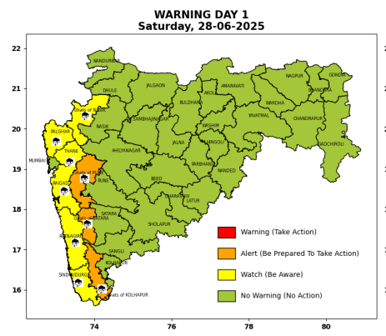 | 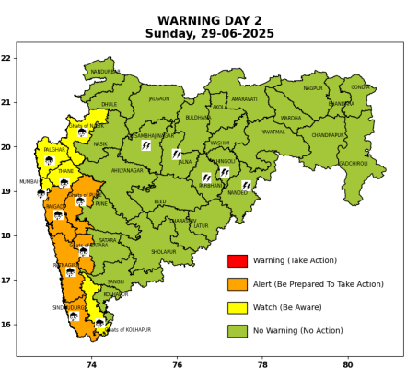 | 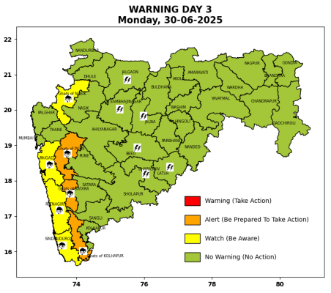 | 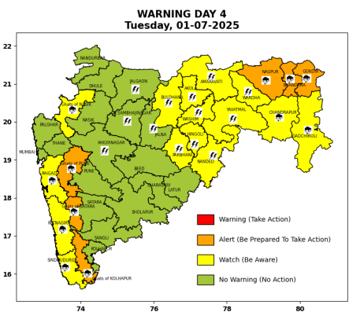 | 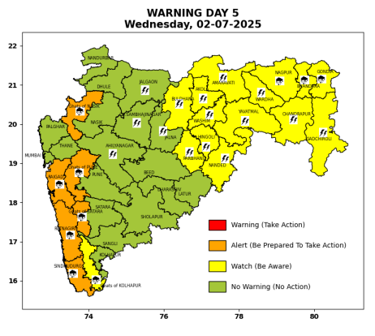

Pune, Lohegaon and Pashan observations at 0830 hrs. IST of Today
 | Temperature (°C) |  |  |  |  | Humidity (%) |  |  |  | Rainfall (mm)
 | Max.  past  24 hrs | Dep.  from  normal | Min.  past  24 hrs. | Dep.  from  normal | Dry  Bulb | At 0830 hrs. IST | Dep.  From  normal | At 1730  hrs. IST of y’day | Dep.  from  normal | Past  24 hrs. | Since  1st June | Dep.  from  normal
PNE | 28.2 | -1.5 | 21.7 | -1.1 | 25.2 | 80 | -1.0 | 79 | 4 | 1.5 | 262.6 | 123.1
PSN | 27.4 | - | - | - | - | - | - | 87 | - | - | - | -
LHG | 29.4 | -1.6 | 23.9 | 2.9 | 26.9 | 67 | -13 | 72 | 4 | 2.6 | 245.0 | 152.2

 |  |  |  |  |  |  | Local (Pune and neighbourhood) forecast
Max./Min. Temperature (°C) |  |  |  |  |  |  |  |  | Weather
Date | Pune | Pashan | Lohegaon | Chinchwad | Lavale | Magarpatta | NDA | Koregoan Park
28/06/25 | 29 / 21.7* | 29 / -- | 31 / 23.9* | 29 / 22.0* | 29 / 21.7* | 31 / 23.6* | 29 / 22.6* | 30 / 23.4* | Generally cloudy sky. Light rain very likely. (Heavy to very heavy rainfall at isolated places in ghat areas)
29/06/25 | 31 / 22 | 30 / 21 | 32 / 24 | 29 / 22 | 29 / 22 | 31 / 24 | 29 / 23 | 31 / 24 | Generally cloudy sky. Light rain very likely. (Heavy to very heavy rainfall at isolated places in ghat areas)
30/06/25 | 30 / 22 | 29 / 21 | 31 / 24 | 28 / 22 | 28 / 22 | 30 / 24 | 28 / 23 | 30 / 24 | Generally cloudy sky. Light rain very likely. (Heavy to very heavy rainfall at isolated places in ghat areas)
01/07/25 | 30 / 23 | 29 / 22 | 31 / 25 | 28 / 23 | 28 / 23 | 30 / 25 | 28 / 24 | 30 / 25 | Generally cloudy sky. Light rain very likely. (Heavy to very heavy rainfall at isolated places in ghat areas)
02/07/25 | 29 / 23 | 28 / 22 | 30 / 25 | 27 / 23 | 27 / 23 | 29 / 25 | 27 / 24 | 29 / 25 | Generally cloudy sky. Light to moderate rain very likely. (Heavy to very heavy rainfall at isolated places in ghat areas)
03/07/25 | 28 / 22 | 27 / 21 | 29 / 24 | 26 / 22 | 26 / 22 | 28 / 24 | 26 / 23 | 28 / 24 | Generally cloudy sky. Light to moderate rain likely.
04/07/25 | 28 / 22 | 27 / 21 | 29 / 24 | 26 / 22 | 26 / 22 | 28 / 24 | 26 / 23 | 28 / 24 | Generally cloudy sky. Light to moderate rain likely.
Rainfall Distribution |  |  | Rainfall Categories | Rainfall (mm) |  | Cloud condition |  |  |  | Rainfall Intensity |  | Range
Widespread (W) | 76-100% |  | Very Light rain | Trace to 2.4 mm |  | Mainly clear sky |  | 1-2 oktas |  | Light Spell |  | 1 cm/hr
 |  |  | Light rain | 2.5 to 15.5 mm |  | Partly cloudy sky |  | 3-4 oktas |  | Moderate Spell |  | 1-2 cm/hr
Fairly Widespread (FW) | 51 – 75% |  | Moderate rain | 15.6 to 64.4 mm |  | Generally cloudy sky |  | 5-7 oktas |  | Intense Spell |  | 2-3 cm/hr
Scattered (S) | 26 – 50% |  | Heavy rain | 64.5 to 115.5 mm |  | Overcast |  | 8 oktas |  | Very Intense Spell |  | 3-5 cm/hr
isolated (I) | 1 – 25% |  | Very heavy rain | 115.6 to 204.4 mm |  |  |  |  |  | Extremely Intense Spell |  | 5-10 cm/hr
D (D) | No Rain |  | Extremely heavy rain | ≥ 204.5 mm |  |  |  |  |  | Cloudburst |  | > 10 cm/hr
Probability Terms in %: |  |  | Heavy snow | 6.5 to 11.5 cms water equivalent of rain
unlikely | < 25 |  | Very heavy snow | 11.6 to 20.4 cms water equivalent of rain
likely | between 25 50
very likely | between 51 75
most likely | >75
* = realized temperature
Mumbai (Colaba) |  |  |  | Nagpur (AP)
Date 2025 | T max °C | T min °C | Weather | T max °C | T min °C | Weather
28/06 | 31 | 26 | Generally cloudy sky with moderate rain. | 34 | 25 | Generally cloudy sky with a few spells of rain or thundershowers.
29/06 | 30 | 25 | Generally cloudy sky with heavy rainfall. | 34 | 25 | Generally cloudy sky with a few spells of rain or thundershowers.
30/06 | 30 | 25 | Generally cloudy sky with moderate rain. | 33 | 25 | Generally cloudy sky with a few spells of rain or thundershowers.
01/07 | 31 | 25 | Generally cloudy sky with moderate rain. | 33 | 25 | Generally cloudy sky with a few spells of rain or thundershowers accompanied with Lightning.
02/07 | 31 | 26 | Generally cloudy sky with moderate rain. | 31 | 25 | Generally cloudy sky with a few spells of rain or thundershowers accompanied with Lightning.
03/07 | 30 | 26 | Rain. | 31 | 25 | Generally cloudy sky with possibility of rain or thunderstorm.
04/07 | 30 | 26 | Rain. | 31 | 25 | Generally cloudy sky with possibility of rain or thunderstorm.

